Task 1

What do you understand by exceptions

An event that occurs during the execution of a program and disrupts its normal flow. It is an object that describes an error condition and is thrown by code that encounters an abnormal condition.

Task 2

Types of Exceptions

* Checked Exceptions
  + IOException
  + SQLException
  + FileNotFoundException
  + ClassNotFoundException
* Unchecked Exceptions or runtime exceptions
  + NullPointerException
  + ArrayIndexOutOfBoundsException
* Errors
  + OutOfMemoryError
  + StackOverflowError

Task 3

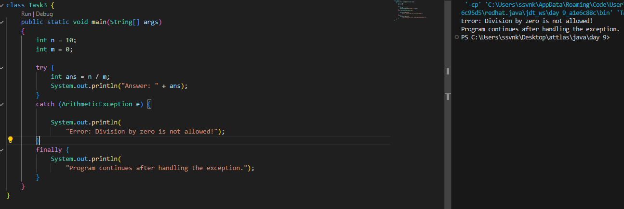

Arithmetic Exception - Unchecked Exceptions or runtime exceptions

Task 4

List of checked and unchecked exceptions – ref Task 2

Task 5

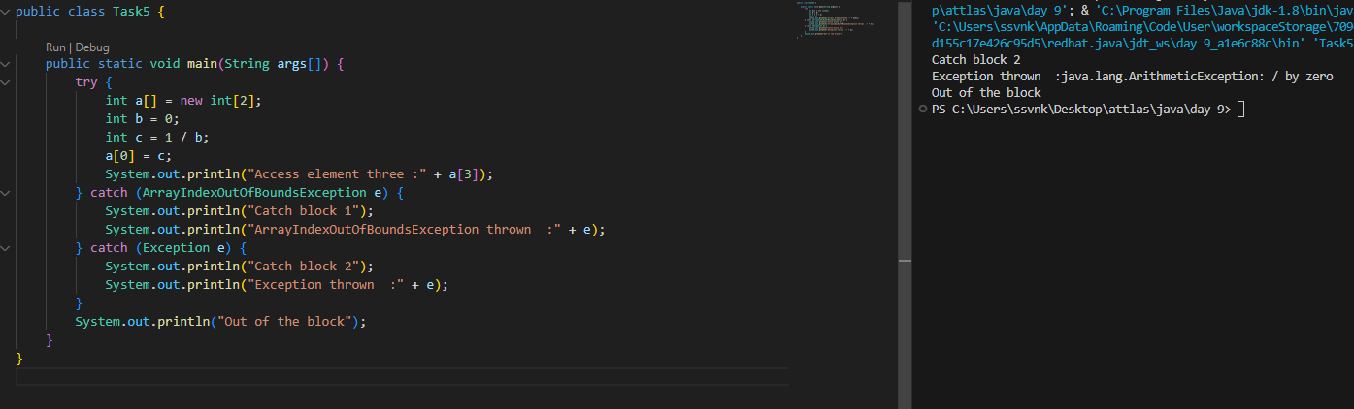

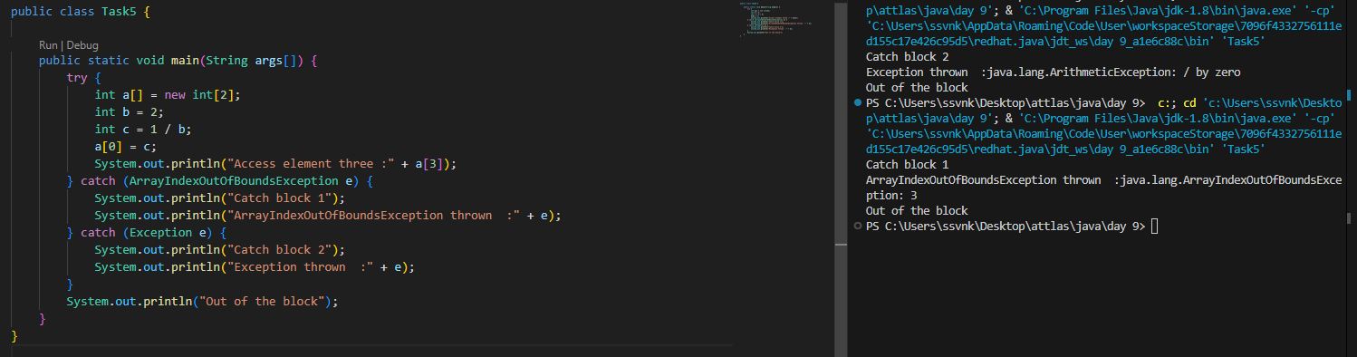

Task 6

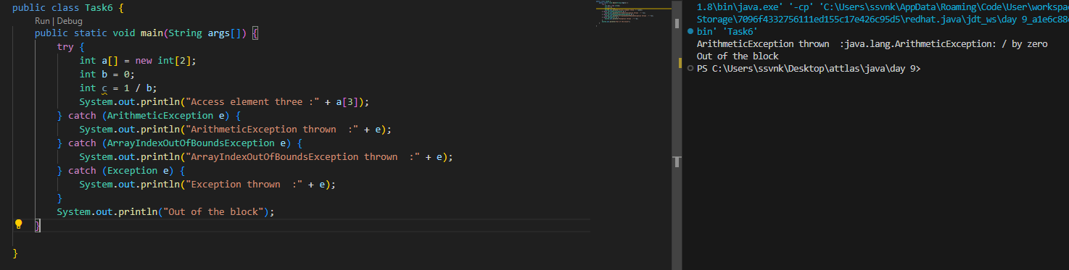

Output:

ArithmeticException thrown :java.lang.ArithmeticException: / by zero

Out of the block

Reason:

int b = 0;

int c = 1 / b;

trying to divide by 0

Task 7

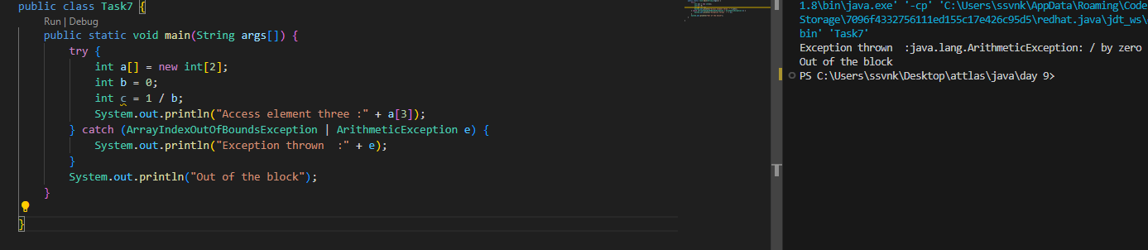

Task 8

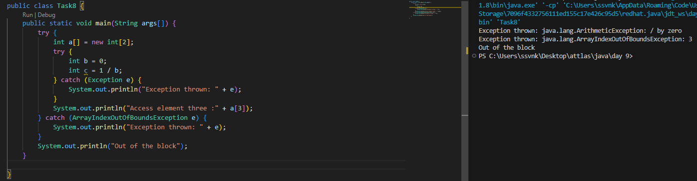

Task 9

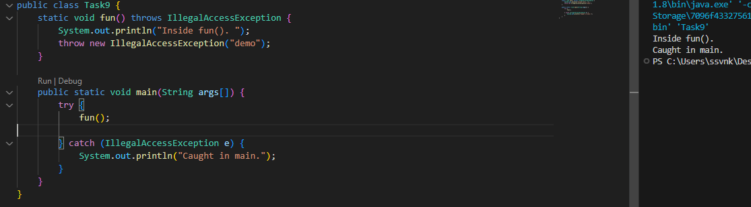

Task 11

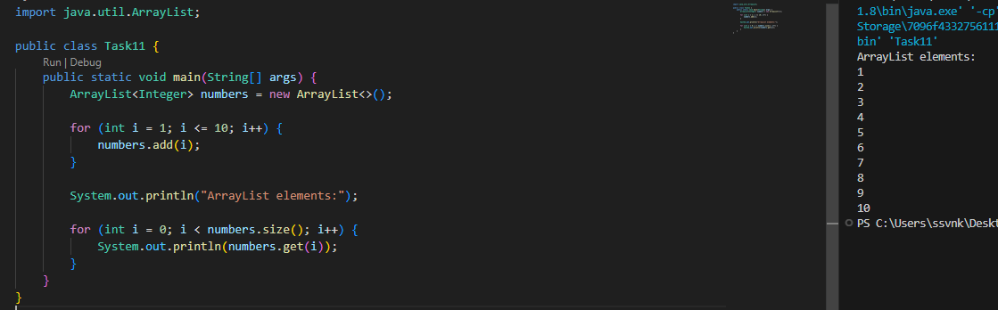

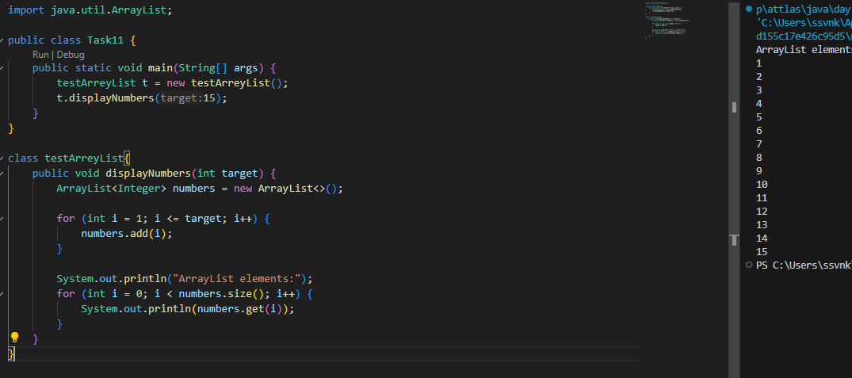

Task 12

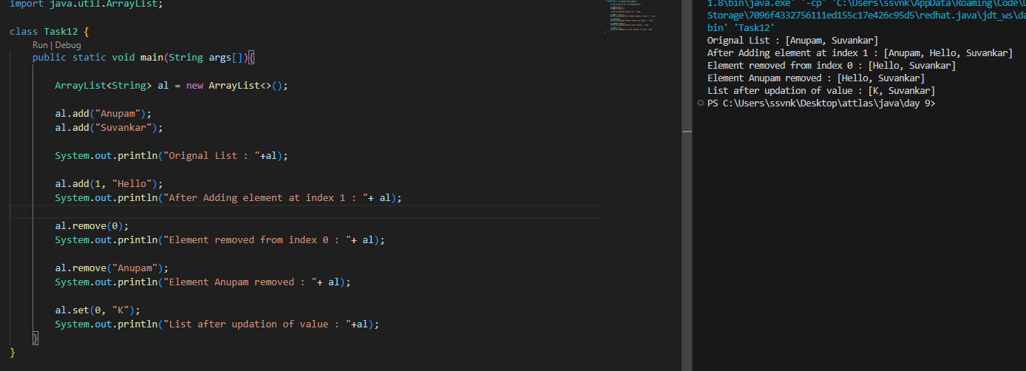

Task 13

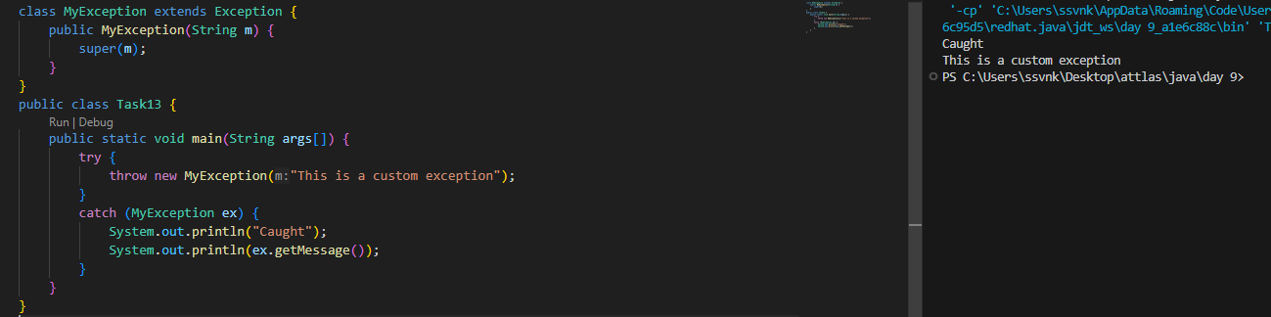

Task 14

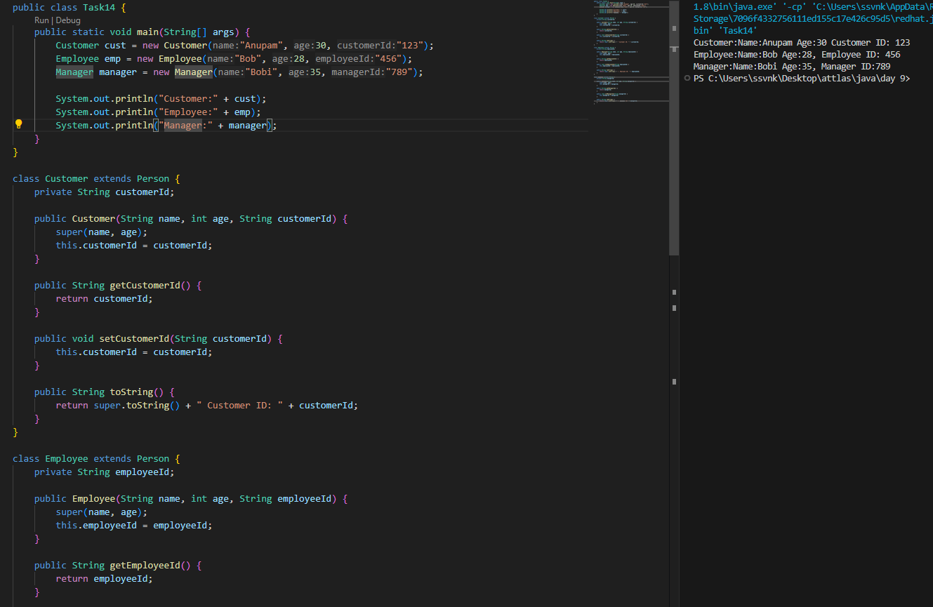

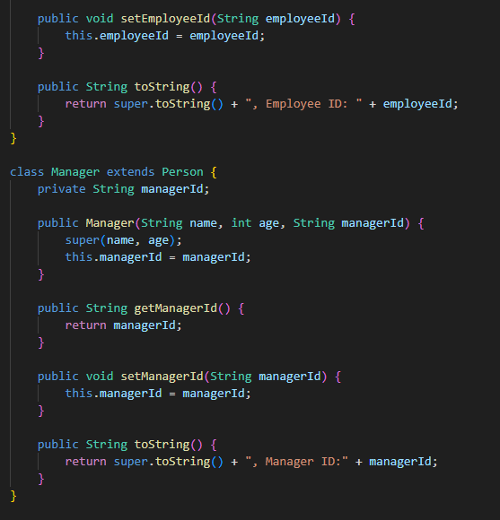

Task 15

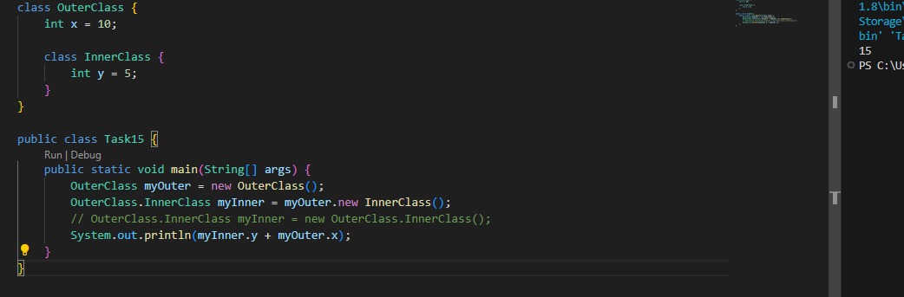

Task 16

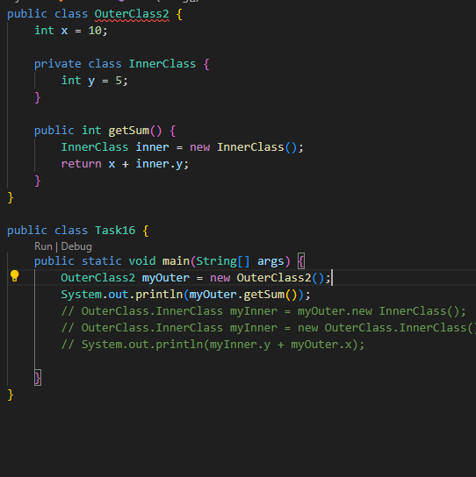

Task 17

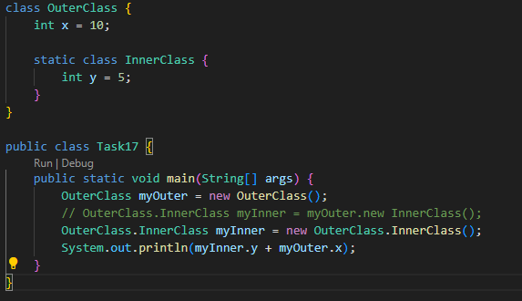

Task 18

